Answer key Computer Practical ‘Stochastic models of infectious disease dynamics in small populations’

# 1. Stochastic SIR model.

1. Do one simulation`below. The code will produce 2 figures: epidemic curve and X vs Y:

Answer: Examples of the outcome

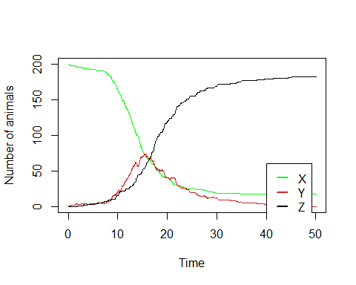

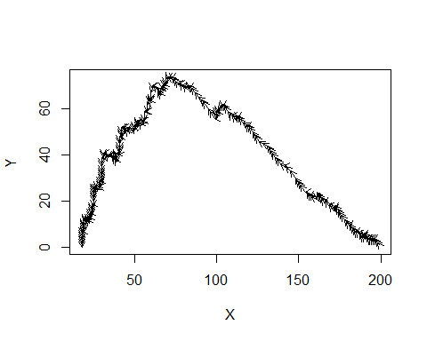

1. Click Run the simulation a couple of times. Describe the differences between the different runs. How long do the outbreaks take? What is the peak number of infected people? How many are still susceptible at the end? How does this relate to what we saw in the deterministic model?

Answer: Everytime you run the model it will produce a different trajectory. Sometimes the infection will die out very quickly and sometimes it takes more time. The timing and height of the peak differs for each run.

* Run the model multiple times:
* Plot a histogram of the final size of the simulations by selecting the number of recovered individuals for Y = 0.

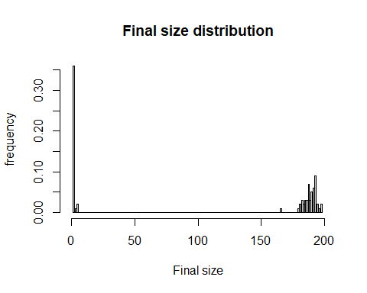

1. What do you see? Calculate the mean final size. Why is the mean result of 100 runs with the stochastic model not equal to the result of the deterministic model? Estimate the probability of a major outbreak from the 100 model runs.

Answer: The final size distribution is bimodal with one peak near 0 and a peak near 200. The average is somewhere in between (around 100) but is not very informative, because outbreaks are either minor or major.   
The proportion of major outbreaks is around 0.67.

1. Change the population size to N = 100, and repeat the analyses of the final sizes. Does the probability of a major outbreak change if the population size is smaller? Now change R0 and repeat it again. How does that affect the final size distribution?
2. Answer: The proportion of major outbreaks is still around 0.67 if you change the number of individuals. The bimodal is distribution is less “sharp”.   
   Changing R0 does make a difference. The proportion of major outbreaks increases with R0.

# 4. Stochastic model with birth/immigration and death/emigration

Add birth and death to the model by changing this code. Also add three extra variable DX, DY and DZ to count the number of dead susceptibles, infected and recovered individuals. To keep the population constant the number of births should equal DX + DY +DZ.

1. Run the model, customize the graph, make a graph of Y against X, as in exercise 3a.
2. Look at the graph of X, Y, and Z in time, and the graph of Y against X (bottom). Run the model a couple of times. How do the graphs differ from the deterministic model?

Answer: In contrast to the deterministic model with demography, the infection can go extinct.

We will now compare the long-term dynamics related to the initial conditions. Two initial conditions will be considered: (1) starting with a susceptible population and one infected individual, and (2) starting in the endemic steady state which will be determined from the deterministic model.

1. For the second initial condition we need the steady state of the deterministic model.Calculate values of the steady state of the deterministic model.

We will compare the long-term dynamics by two output parameters: the number of outbreaks going extinct, and the distribution of extinction times over many simulations. Therefore, we need the extinction time as output from the simulation.

1. Start simulations with a susceptible population and one infected. Make a histogram of the extinction times. Calculate in what proportion of simulations the outbreak got extinct.

Answer: The proportion of minor outbreaks (extinction) is similar to that of the model without demography. Additionally some will go extinct after the first wave.

1. Repeat (c) and (d) with simulations starting in the endemic steady state. Describe the differences in extinction behaviour between the two initial condition. How do explain the differences?

Answer: When starting the endemic equilibrium no minor outbreaks occur, which results in less extinctions within the simulation period

# ADDITIONAL QUESTIONS

1. Make the population size smaller (e.g. N = 20) and larger (e.g. N = 1000) and repeat (c) and (d) for the endemic equilibrium as starting condition. How do the results differ? How do you explain this? What will you expect for very large populations?